

TC
ISTANBUL MEDIPOL UNIVERSITY
FACULTY OF BUSINESS AND MANAGEMENT SCIENCES
MANAGEMENT INFORMATION SYSTEMS

PROGRAMMING II
FINAL EXAM ASSIGNMENT

Instructor of the Course
Assistant Professor Mustafa Coruh

June – 2023

Student Name Surname | : Semih Enes DOĞAN- Abdullah DEMİRKAYA- Azra GÜLSUNAY- Muharrem Can DORUK – Yusuf Can KINALI
Student number | :9A200025- 9A200017- 9A200052- 9A200001- 9A200028

Project Assignment for Final Exam

The project will be shown in the classroom/online by making a presentation as a group or individually. The total grade point value of the project is 70 points.
The "Employee Wages Tracking Application (EWTA)" explained here will be made using ASP.NET and C#. The example project can be seen as in http://www.mustafacoruh.com/WEBDers/EWTA_Default.aspx.
The project will consist of 2 parts and 5 tables. The structure of the tables is as follows.
Employee Table | Wage Table | Department Table | Users Table | Categories Table
Empl_ID | Wage_ID | Dept_ID | User_ID | LK_ID
Empl_FName | Empl_ID | Dept_Name | User_Name | Gender
Empl_LName | Wage_Date | Dept_Phone | User_Psw | Title
Empl_BDate | Wage_Amount | Manager_ID | Role_ID | City
Empl_Name (Hesaplama) | Wage_Commission |  |  | Province
Emp _Start_Date | Wage_Total (Hesaplama) |  |  | Country
Empl_Left_Date | Month_ID |  |  | Month
Empl_Address | Wage_Year (Hesaplama) |  |  | Role
Empl_City
Empl_Province
Empl_Phone
Empl_Cell
Empl_Email
Dept_ID
Gender_ID
Title_ID
Empl_Photo
Empl_CV
Empl_CV_File
Empl_CV_Web
Entered_By
Entered_Date
Is_Empl_Active
tbl_Employees | tbl_EmployeeWages | tbl_Departments | tbl_Users | tbl_Lookups

Project: EWTA data will be kept in an Access or SQL Server Database with the tables given above. Relevant data must be entered, updated and reported on the intranet via ASP.NET Web forms. For example, employee and wage data should be entered with a web form and the data should be updated with the help of GridViews or DetailsViews. The sum of the wages of the employees should be graphed on an annual basis, the employee communication report should be created, and the wage lists should be reported on the basis of employee, and employee on the basis of departments.
Preparing the EWTA ASP.NET project in working condition, presenting and uploading the files is worth 100 points. Uploading 17 aspx, 34 cs, database and web.config files by zipping 10 Points and designing the project in a working condition is 50 points, making a live in class/online presentation is 20 points. The project that is not presented live will be considered as a copy and 70 points will be deducted.
User Guide: This Word document will be used for reporting the Project User Guide and will be uploaded to the Mebis/Microsoft Teams related section. The homework will be arranged according to the School project delivery format with this document. The homework should be named as Programming-II-Project-NameSurname.docx and delivered from the homework section. The name and surname of the group leader student will be written in the Name and Surname section here.
The preparation of the Project's User's Guide and uploading it is worth 20 Points. User Guide report must be in accordance with the school's project delivery standards and must explain what each form does in details.
The project will be evaluated with the following Grade Rubric:
Project Grade Rubric
Explanation | Full Points | Scores and Comments Received
Running Project | 50 Points
Presentation | 20 Points
User Guide | 20 Points
Zip Files | 10 Points
Total | 100 Points

After you write your name and student numbers on the first page, do not delete the sections up to here. Add your own user guide information after this page.

Employe Wages Tracking Application (EWTA) User Guide

The features of the application are explained in detail in this User guide for users. Incomprehensible situations, error reporting and requests for adding new features should be shared with the IT Department Technical Service that prepared this project. The relevant service can be contacted by calling 111 222 3333 or by emailing mcoruh@gmail.com .
Switchboard
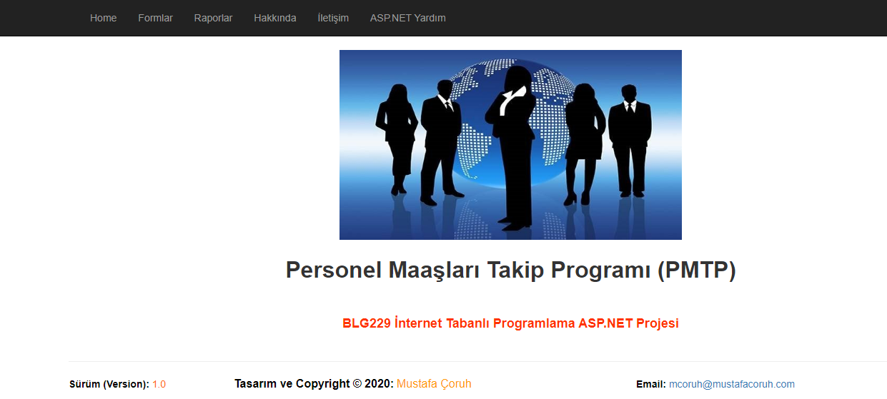
This Default.aspx file, which is the main page of the project, is the main file and interface where all the features of the application are used. With the help of the buttons, you will be directed to the forms that will perform our transactions.
……

